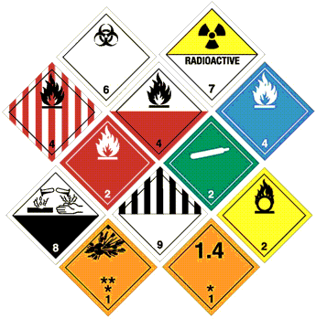

What a customer needs to know to fill out a Hazardous Materials or Dangerous Goods Shipment*.

- Customer must provide the correct UN Number.

- Customer select provide the correct Proper Shipping Name

- HM and DG are classified by either Class or Package Group (PG). Customer must select the correct Class or Package Group.

- (DG ONLY) Identify the maximum quantity for the Package Group or Class the customer will use. That will be under "1 max qty" or "2 max qty". Then select the appropriate Packaging Instruction, either "1 pkg inst" or "2pkg inst". Only enter a package instruction that is a number, not the one with a "Y" in front of it.

- Customer must enter a technical name, if required. A Technical Name is required if it is signified by a "G" in the Hazardous Materials Table, Column 1; or if it is signified by an asterix in the IATA DGR Appendix B. The technical name itself can be found in their Material Data Safety Sheets (MSDS).

What an agent needs to do on a Hazardous Materials or Dangerous Goods Training

- Forms. Go to "Customize" to "Forms", and the third from the bottom is the Shipper's Declaration for Dangerous Goods. The last one is the OP900LL for Hazardous Materials. Both of them need to be setup with a regular printer. Click on the item, press "Change", and select the printer.

- You need to enter the Hazardous Materials and Dangerous Goods preferences. Go to "Customize" to "Shipping Profiles". If they only ship domestic, you will only need to do domestic. If they ship International Dangerous Goods, you will need to set those up as well.

The Fields you need to fill out are:

- DG Emergency Phone Number: The 24 hour support number for Dangerous Goods.
- DG Name of Signatory: The name of the person shipping Dangerous Goods. If you have multiple DG shippers, don't default.
- DG Regulations: IATA. It will always be IATA unless it is specified they are doing express ORM-D.
- Place of Signatory: City and state of the shipper.
- Title of Signatory: Job title of the shipper if single DG shipper.
- HazMat Emergency Phone Number: The 24 hour support number for Dangerous Goods.
- HazMat Name of Signatory: Name of HazMat shipper if only one HM shipper.
- HazMat Offerer Name: Name of the person or company who provides the 24 hour emergency HazMat support.
- HazMat Packaging Name: Only use if *outer* packaging is always the same for all of their products, such as fiberboard box.

- You need to show the customer how to fill out Databases. You can either do that from the Databases Screen, or from the HM or DG screen by entering a HM ID or DG ID. They need to be clear that the purpose of doing this is so that when they ship in the future, all they have to do is click on the ID dropdown, add the item to the shipment, and ship.

